Computer Vision (CV) term goes beyond just taking (importing) images and capturing videos, but it also covers the idea of understanding what this image is. Computer Vision covers a wide range field for the topics related to machine vision, path tracing, and image processing. Precisely, objects detection, classification, recognition, and features extraction.

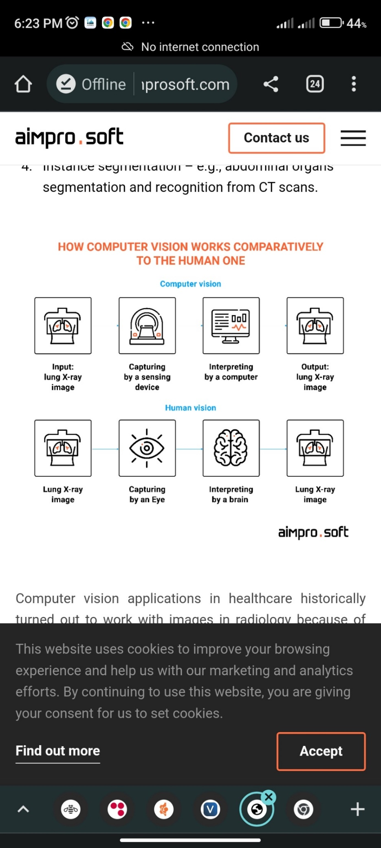By using a set of methods, it gives the computer the ability to “see” and extract information from what it sees. To teach a computer to “see,” deep learning technologies are used. A lot of data is collected to highlight features and combinations of features for further identification of similar objects.

Suggestions of App. for CV in our project :

* Following meals of every patient.
* Following who is not wearing a mask in specific areas.
* Following-up physiotherapy exercises for patient to do it with a correct method.
* Count persons in the room and make a warning to reduce the persons in it.

We can make a connection between systems to take advantages of this feature ( measuring the amount of blood ):

Computer vision also can measure the amount of blood lost during surgeries to determine whether the patient has reached a critical stage. Triton, developed by Gauss Surgical, is one such application that effectively monitors and estimates the amount of blood lost during surgery. It helps surgeons to determine the amount of blood needed by the patient during or after the surgery.

And in these links we will find similar of these applications:

[shorturl.at/xzMW1](http://shorturl.at/xzMW1)

[shorturl.at/ckUY5](http://shorturl.at/ckUY5)  
  
[shorturl.at/cjzDJ](http://shorturl.at/cjzDJ)  
  
playlist on youtube:

[shorturl.at/ADEK7](http://shorturl.at/ADEK7)

other video   
[shorturl.at/sABI7](http://shorturl.at/sABI7)